LSI KEYWORDS ONLINE TOOL
What is LSI?
Latent Semantic Indexing (LSI) is a mathematical method used to determine the relationship between terms and concepts in content. The contents of a webpage are crawled by a search engine and the most common words and phrases are collated and identified as the keywords for the page.

In simple terms -
LSI Keywords are essentially keywords related to the keyword that you search for on search engines such as Google. In short, they are keywords that are related to your main term. They help support your content and give it more context for both the search engines and your users.

Example of how the LSI graph tool works?

So we did a search for the keyword “wordpress hosting”

Here are the results below!
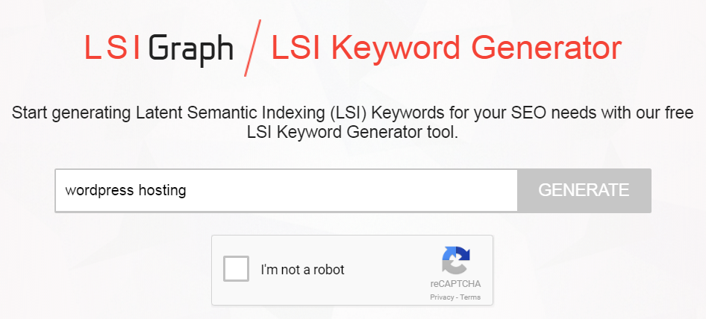

Results:

    - wordpress hosting service
    - wordpress hosting comparison
    - free wordpress hosting
    - cheapest wordpress hosting
    - joomla hosting
    - secure wordpress hosting company
    - web hosting
    - godaddy wordpress hosting
    - shared web hosting services
    - managed wordpress hosting reviews
    - wordpress hosting review for business
    - bluehost and wordpress
    - free wordpress web hosting
    - godaddy managed wordpress
    - godaddy templates
    - go daddy quick blog
    - wordpress hosting reviews
    - wordpress hosting on godaddy
    - web hosting go daddy
    - shared web hosting
    - what is shared hosting
    - ssd shared hosting
    - shared hosting web hosting
    - top shared hosting
    - shared hosting plans
    - unlimited shared web hosting
    - best wordpress hosting 2015
    - best wordpress hosting
    - web hosting vs wordpress hosting
    - blog hosting sites comparison
    - wordpress hosting plans
    - cheap wordpress hosting
    - best hosting for wordpress
    - business wordpress hosting
    - best wordpress hosting sites
    - web hosting for wordpress
    - best managed wordpress hosting
    - secure wordpress hosting service
    - managed wordpress hosting service
    - wordpress hosting company
    - managed wordpress hosting
    - wordpress site hosting
    - wordpress hosting
    - one engine wordpress
    - engine wordpress theme
    - dedicated wordpress hosting
    - wordpress hosting godaddy
    - make wordpress easy
    - wp engine hosting
    - top web hosting for wordpress
    - top web hosting sites 2014
    - fast hosting for wordpress
    - fastest wordpress hosting
    - hosting sites for wordpress
    - web hosting with wordpress
    - wordpress web hosting reviews
    - easy wordpress hosting
    - easy 1 hosting
    - easy web hosting

Document made by http://www.digitalfrog.com.au/

